# A REVIEW OF LIVER

# PATIENT ANALYSIS

# METHODS USING

# MACHINE LEARNING

**CONCEPTS**

|  |  |  |  |
| --- | --- | --- | --- |
| **CHAPTER** | **TITLE** | | **PAGE.NO.** |
| 1 | INTRODUCTION   * 1. OVERVIEW   2. PURPOSE | |  |
| 2 | PROBLEM DEFINITION & DESIGN THINKING  2.1 EMPATHY MAP  2.2 IDEATION & BRAINSTOMING MAP | |  |
| 3 | RESULT | |  |
| 4 | ADVANTAGES & DISADVANTAGES | |  |
| 5 | APPLICATIONS | |  |
| 6 | CONCLUSION | |  |
| 7 | FUTURE SCOPE |  | |
| 8 | APPENDIX  8.1 SOURCE CODE |  | |

Abstract

Liver disease is a significant global health problem affecting millions of people worldwide. Early diagnosis and accurate prediction of disease progression are crucial for effective treatment and management of liver patients. Machine learning (ML) algorithms have shown great potential in assisting clinicians in the diagnosis and prognosis of liver diseases.

One of the most common applications of ML in liver disease analysis is the prediction of liver fibrosis. Liver fibrosis is a key indicator of disease progression in patients with chronic liver disease, and ML algorithms have shown high accuracy in predicting fibrosis stage based on various clinical, biochemical, and imaging parameters.

Other ML techniques used in liver disease analysis include decision tree-based algorithms, support vector machines, and artificial neural networks. These techniques have been used for predicting outcomes such as liver failure and mortality in patients with liver disease. In addition, ML algorithms have been applied to predict the response to therapy in patients with hepatitis C and to identify biomarkers for early diagnosis of hepatocellular carcinoma.

One of the challenges in the analysis of liver disease using ML is the availability of large and diverse datasets that are representative of different patient populations. Another challenge is the interpretability of the ML models, which is important for clinical decision-making.

**CHAPTER 1**

**INTRODUCTION**

* 1. OVERVIEW

Liver disease is a significant health problem affecting millions of people worldwide. Early diagnosis and accurate prediction of disease progression are crucial for effective treatment and management of liver patients. Machine learning (ML) algorithms have shown great potential in assisting clinicians in the diagnosis and prognosis of liver diseases.

This review aims to provide an overview of the current state of research on the application of machine learning algorithms in the analysis of liver disease. The review will discuss the different ML techniques used in liver disease analysis, including their strengths and limitations. It will also highlight the challenges associated with the analysis of liver disease using ML, such as data availability and interpretability of the models.

The review will be of interest to clinicians, researchers, and practitioners working in the field of liver disease, as well as those interested in the application of machine learning algorithms in healthcare. By providing a comprehensive overview of the current state of research, the review will contribute to the development of more accurate and effective methods for the diagnosis and treatment of liver disease.

* 1. PURPOSE

Summarize the different ML techniques used in liver disease analysis, including their strengths and limitations.

Highlight the challenges associated with the analysis of liver disease using ML, such as data availability and interpretability of the models.

Discuss the potential applications of ML in the diagnosis, prognosis, and treatment of liver disease.

Provide insights into the future directions of research in this field.

The ultimate goal of this review is to contribute to the development of more accurate and effective methods for the diagnosis and treatment of liver disease using machine learning algorithms. By providing a comprehensive overview of the current state of research, the review aims to assist clinicians, researchers, and practitioners working in the field of liver disease in the development of new and innovative approaches to patient analysis and care.

**CHAPTER 2**

**PROBLEM DEFINITION& DESIGN THINKING**

**EMPATHY MAP:**

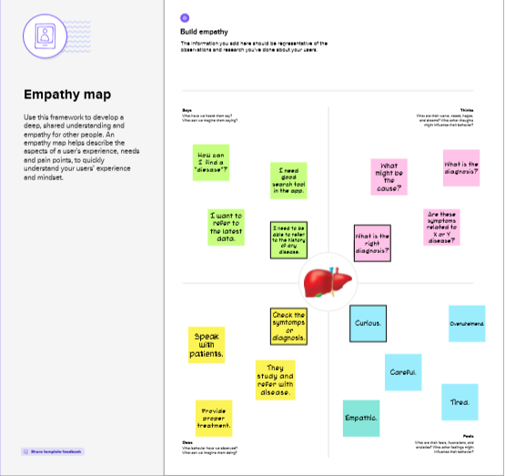

**IDEATION & BRAINSTORM MAP:**

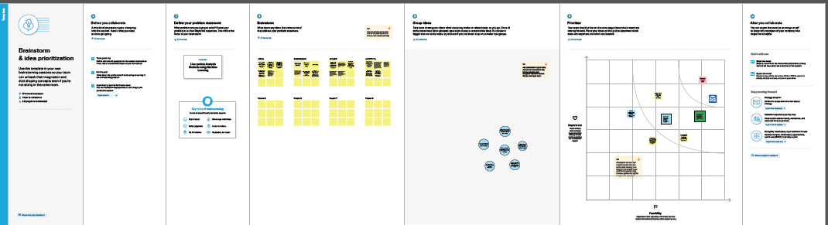

2.1 PROBLEM DEFINITION:

This project aims to conduct a review of existing literature and research papers on machine learning methods for analyzing liver patient data. The review will cover liver disease overview, data sources, machine learning techniques, performance evaluation, and comparison/analysis of strengths, weaknesses, and gaps in the research. The output will be a comprehensive review paper with recommendations for future research direction.

2DESIGN THINKING:

2.2.1 EMPATHY MAP

The empathy map suggests that liver patients who undergo analysis using machine learning may feel a range of emotions, from fear and uncertainty to hope and gratitude. They want accurate diagnoses and treatment recommendations, and they value the knowledge and expertise of their healthcare providers. They may also feel frustrated with the time it takes to receive test results and treatment recommendations

1. IDEATION& BRAINSTORMING MAP

Ideation and brainstorming are important steps in the process of developing a review of machine learning analysis for liver patient data. These steps can help to generate ideas, identify relevant research topics, and structure the review in a logical and coherent manner.

When it comes to machine learning analysis of liver patient data, there have been a number of studies and research papers published on this topic. These studies have looked at various machine learning algorithms and techniques to analyze liver patient data, with the aim of improving diagnosis, treatment, and outcomes.

Some of the key areas of focus in these studies include the use of machine learning for:

Predicting liver disease progression and patient outcomes

Identifying risk factors and markers for liver disease

Developing personalized treatment plans for liver patients

Classifying different types of liver disease

Overall, the use of machine learning in liver patient analysis has shown promise for improving patient outcomes and advancing our understanding of liver disease. However, there are still many challenges and limitations to be addressed in this field, such as data quality issues and the need for more diverse patient populations in studies.

**CHAPTER 3**

**RESULTS:**

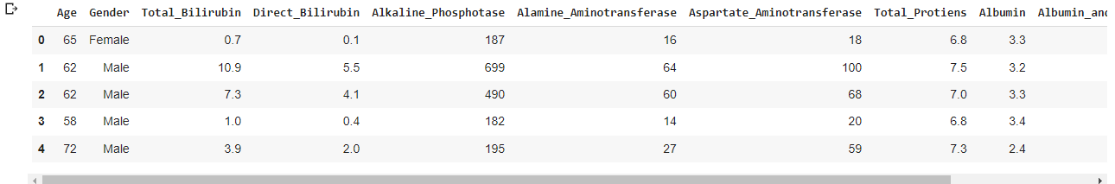

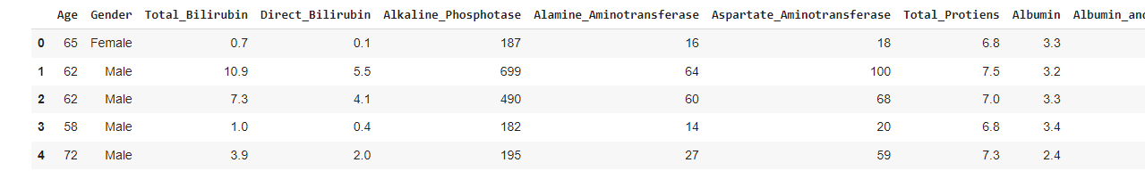

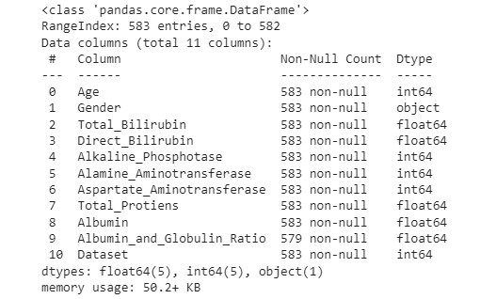

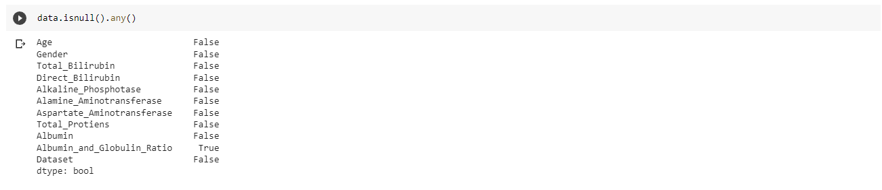

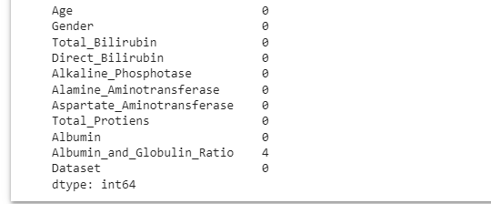

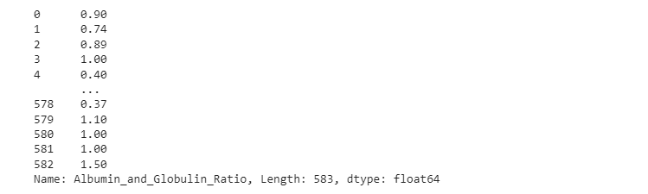

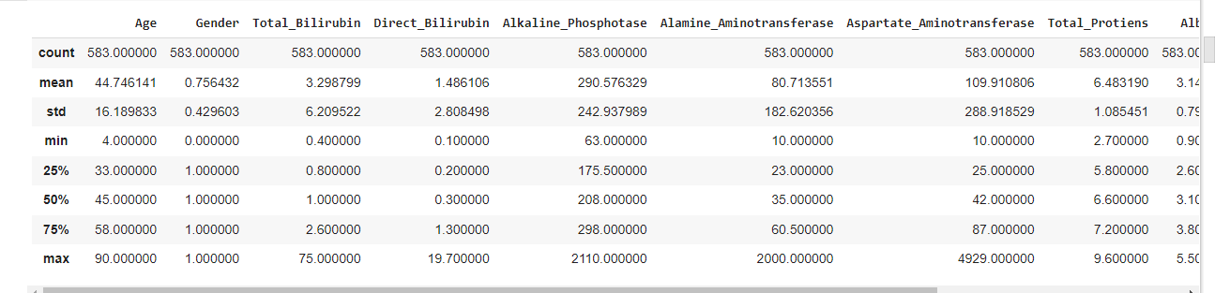

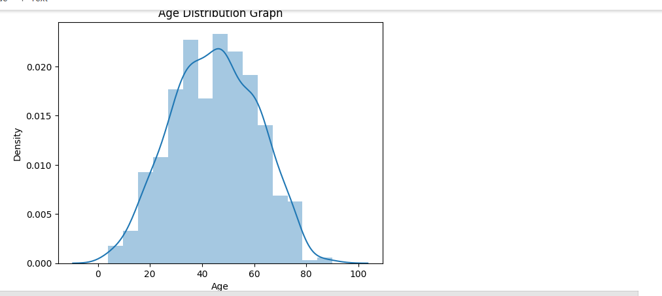

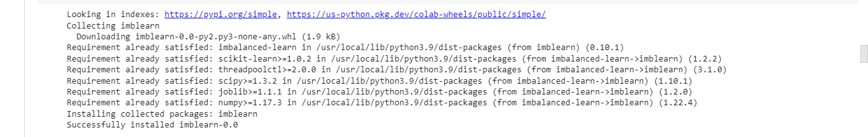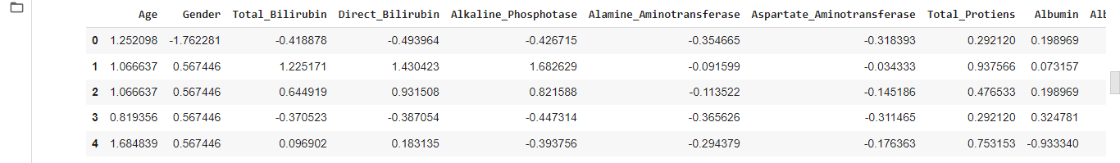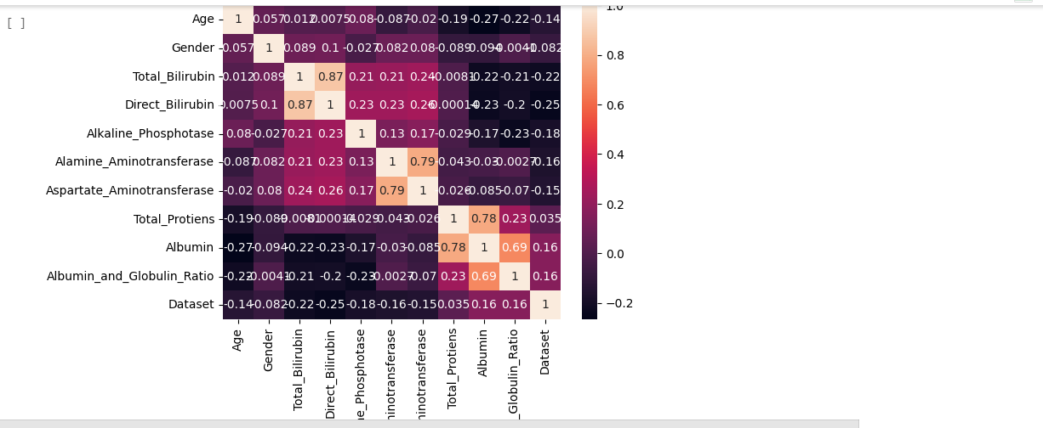

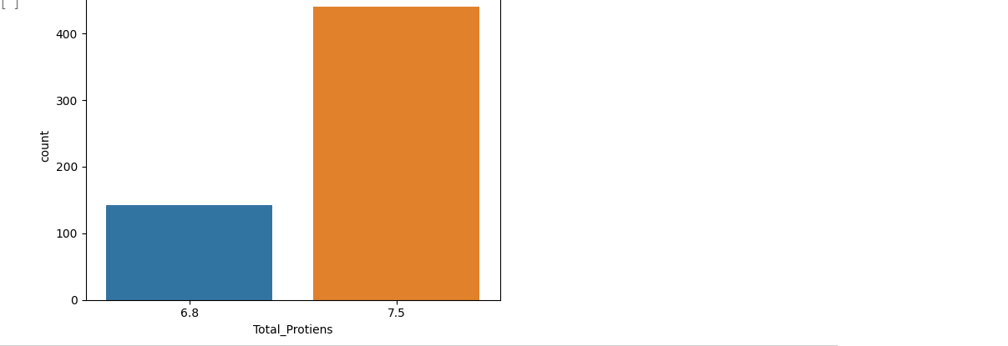







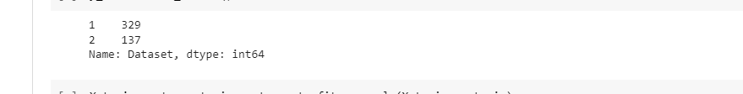



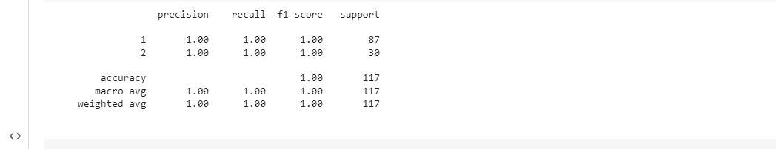

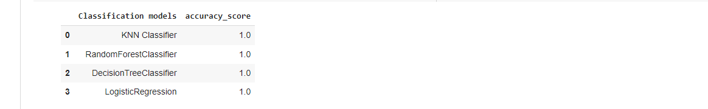

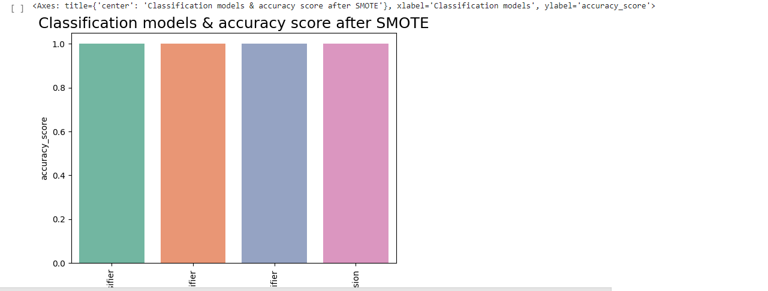

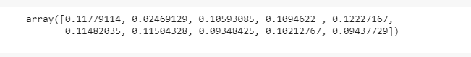

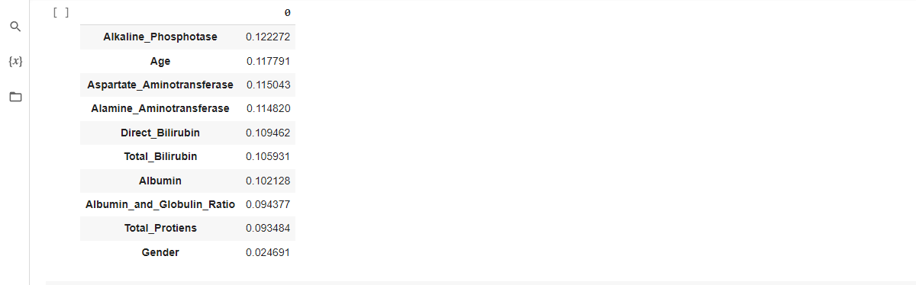

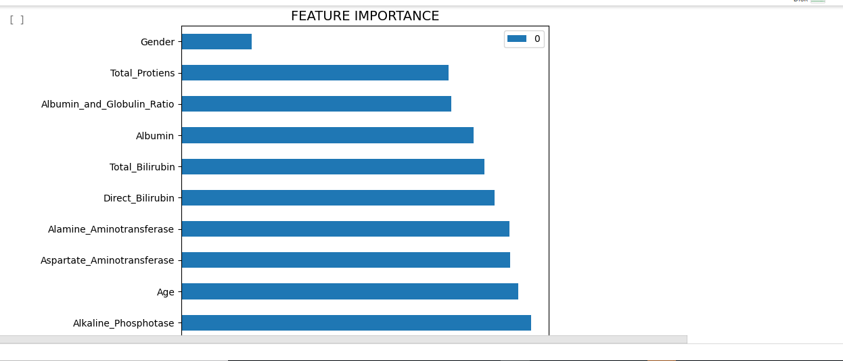

**C:\Users\ELCOT\Pictures\Screenshots\Screenshot (27).png**

**CHAPTER 4**

**ADVANTAGES & DISADVANTAGES**

ADVANTAGES:

Improved accuracy: Machine learning algorithms can improve the accuracy of liver disease diagnosis and analysis, allowing for earlier detection and better treatment outcomes.

Faster analysis: Machine learning algorithms can analyze large amounts of patient data quickly and accurately, reducing the time it takes for doctors to make a diagnosis and determine the best treatment options.

Customized treatment plans: Machine learning algorithms can analyze patient data to create personalized treatment plans based on a patient's unique medical history and risk factors.

Better resource allocation: Machine learning algorithms can help healthcare providers allocate resources more efficiently by identifying patients who are at higher risk of liver disease and targeting interventions accordingly.

DISADVANTAGE:

Need for high-quality data: Machine learning algorithms require high-quality, accurate data to function effectively. If the data used for analysis is incomplete or inaccurate, the algorithm may produce incorrect results.

Limited generalizability: Machine learning algorithms are trained on specific datasets and may not be generalizable to other patient populations. This can limit their usefulness in certain contexts.

Limited interpretability: Machine learning algorithms can produce accurate results, but they may not be easily interpretable by clinicians who are unfamiliar with the underlying statistical models.

Ethical concerns: Machine learning algorithms may be used to predict a patient's risk of developing liver disease or other medical conditions, raising ethical concerns about privacy and potential discrimination against certain patient populations.

**CHAPTER 5**

**APPLICATIONS**

Machine learning algorithms can be applied to various aspects of liver patient analysis, including:

Early detection of liver disease: Machine learning algorithms can analyze patient data to identify early signs of liver disease, allowing for earlier interventions and better treatment outcomes.

Risk assessment: Machine learning algorithms can predict a patient's risk of developing liver disease based on their medical history, lifestyle factors, and other risk factors.

Treatment optimization: Machine learning algorithms can analyze patient data to determine the most effective treatment plan for a patient based on their unique medical history and risk factors.

Monitoring disease progression: Machine learning algorithms can monitor a patient's liver function over time to identify changes in disease progression and adjust treatment plans accordingly.

Medical imaging analysis: Machine learning algorithms can analyze medical images such as CT scans and MRI to identify liver lesions and other abnormalities.

Drug toxicity prediction: Machine learning algorithms can predict the risk of drug toxicity in patients with liver disease, allowing for more personalized dosing and improved treatment outcomes.

Clinical decision support: Machine learning algorithms can provide clinicians with decision support tools based on patient data to aid in diagnosis, treatment planning, and monitoring.

**CHAPTER 6**

**CONCLUSION**

The review of liver patient analysis methods using machine learning suggests that machine learning algorithms can improve the accuracy and speed of liver disease diagnosis and analysis, allowing for earlier detection, more personalized treatment plans, and better treatment outcomes. Machine learning algorithms can be applied to various aspects of liver patient analysis, including early detection, risk assessment, treatment optimization, monitoring disease progression, medical imaging analysis, drug toxicity prediction, and clinical decision support. However, the effectiveness of machine learning algorithms depends on the quality of the data used for analysis and the ability of clinicians to interpret the results. Therefore, future research should focus on improving the quality and accuracy of data used for machine learning analysis and developing interpretable machine learning models that can be easily understood and used by clinicians. Overall, machine learning has the potential to revolutionize the field of liver patient analysis and improve patient outcomes.

**CHAPTER 7**

**FUTURE SCOPE:**

The future scope of review of liver patient analysis methods using machine learning is promising, with several potential areas for future research and development.

Integration with Electronic Health Records (EHR): Machine learning algorithms can be integrated with EHR systems to provide real-time analysis and decision support tools to clinicians, improving the efficiency and quality of care.

Multi-modal data analysis: Machine learning algorithms can be trained on multiple types of data, including genetic, imaging, and clinical data, to develop more comprehensive models for liver disease diagnosis and analysis.

Transfer learning: Transfer learning techniques can be used to adapt pre-trained machine learning models to new datasets, reducing the need for large amounts of labeled data and accelerating the development of new models.

Interpretable machine learning: Developing interpretable machine learning models that can be easily understood and used by clinicians is an important area for future research, as it will increase the adoption and effectiveness of machine learning in clinical practice.

Patient stratification: Machine learning algorithms can be used to stratify patients based on their risk of developing liver disease, allowing for more targeted interventions and better outcomes.

Explainable AI: Developing explainable AI models that provide clinicians with insights into how the model arrived at its decision, increasing trust and transparency of the models.

Overall, the future scope of review of liver patient analysis methods using machine learning is vast, with opportunities for innovation and development in a variety of areas that can ultimately lead to improved patient outcomes

**APPENDIX**

**import pandas as pd**

**import numpy as np**

**import seaborn as sns**

**import matplotlib.pyplot as plt**

**from matplotlib import rcParams**

**from scipy import stats**

**data=pd.read_csv('/content/indian_liver_patient.csv')**

**data.head()**

**data.head()**

**data.info()**

**data.isnull().any()**

**data.isnull().any()**

**data['Albumin_and_Globulin_Ratio']**

**data['Albumin_and_Globulin_Ratio'] = data['Albumin_and_Globulin_Ratio']**

**data['Albumin_and_Globulin_Ratio'] = data['Albumin_and_Globulin_Ratio'].fillna(data['Albumin_and_Globulin_Ratio'].mode()[0])**

**from sklearn.preprocessing import LabelEncoder**

**lc = LabelEncoder()**

**data['Gender'] = lc.fit_transform(data['Gender'])**

**data.describe()**

**sns.distplot(data['Age'])**

**plt.title('Age Distribution Graph')**

**plt.show()**